*General News*

After the success of our Fund-Raising efforts in 2022, with Staff, Patients, and residents, totalled an amazing £1,038, we will again be supporting Derian House Children’s Hospice. In Surgery we have various Easter themed treats and a colouring competition – Please pop in and support Derian House!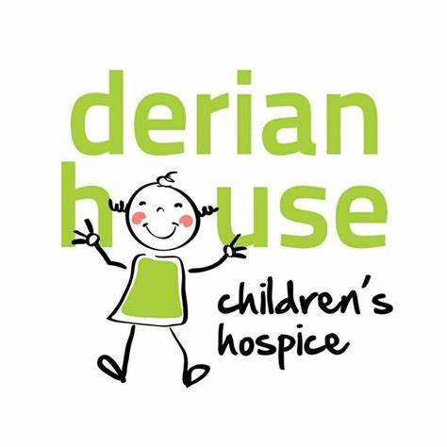

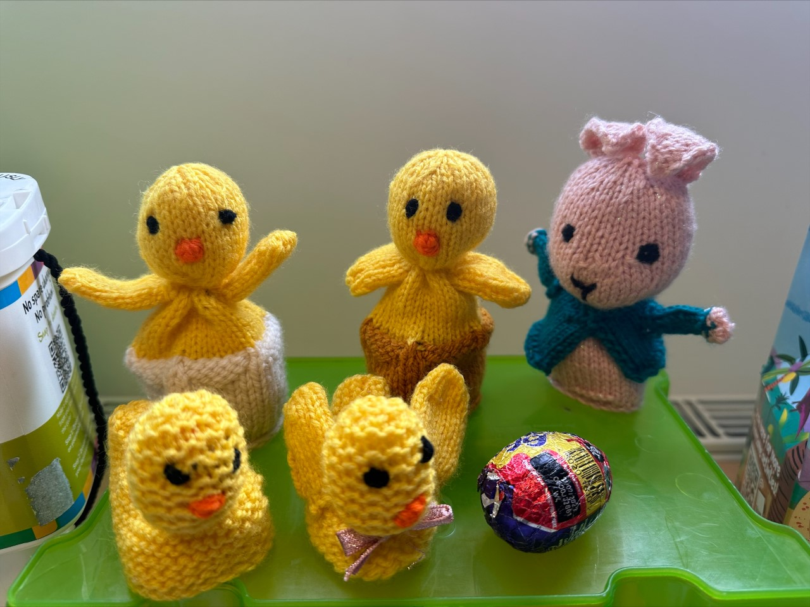

*Upcoming Surgery Events*

Surgery Refurb – this year we will welcome a refurbishment focusing on our reception area and front door access. We hope to provide clearer signage for patients in house, the new signs will be added in the coming weeks with re-branded logo.

Further fundraising – Continuing in support of Derian House Childrens Hospice. Please keep your eyes peeled in Surgery and on our social media and website.

Patient Participation – Your feedback is important to us. We are due to share a patient survey and we hope to have a high uptake in response to provide us with invaluable feedback.

How would you feel about a ‘Saturday Morning Social at RHS’? An opportunity to meet some of the behind-the-scenes Team? Is this something that you would visit?

Let us know your thoughts 😊

***Our patient list is open! If you would like to enquire about registering at the Practice, have any feedback, ideas, or queries, please feel free to pop into the Surgery or contact us on the details below.***

*Caroline Morley, our Reception Supervisor, has been busy knitting some Easter Treats for the littles ones, with all sale proceeds being donated to Derian House Hospice.*

*Pick up one of these unique sweet treats in Surgery from our Reception Team* 😊

***Thankyou Caroline!***

**NATIONAL NO SMOKING DAY 8 MARCH 2023**

Aim is to help encourage as many smokers as possible to quit on No Smoking Day! Contact us in Surgery for help and advice.

[Find Your Local Stop Smoking Service (LSSS) - Better Health - NHS (www.nhs.uk)](https://www.nhs.uk/better-health/quit-smoking/find-your-local-stop-smoking-service/)

*Upcoming Health Campaigns*

**EATING DISORDER AWARENESS WEEK 27/2/23 – 5/3/23**.

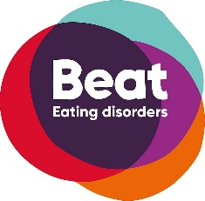





***CONTACT US AT REGENT HOUSE SURGERY***

**01257 442628**

[**Lscicb-csr.regenthousesurgery@nhs.net**](mailto:Lscicb-csr.regenthousesurgery@nhs.net)

[**www.regenthousesurgery@nhs.net**](http://www.regenthousesurgery@nhs.net)

Regent House Surgery Facebook

**OVARIAN CANCER AWARENESS MONTH – MARCH**

Ovarian cancer is a disease that can disrupt the normal function of the ovaries. If it is left unchecked, it can affect other parts of the body too.

[March is Ovarian Cancer Awareness Month | Ovarian Cancer Action](https://ovarian.org.uk/march-ovarian-cancer-awareness-month/)

An international awareness event, fighting the myths and misunderstandings that surround eating disorders

[The UK's Eating Disorder Charity - Beat (beateatingdisorders.org.uk)](https://www.beateatingdisorders.org.uk/)

*Staffing News and Services Update*

Regent House Surgery is a Training Practice and throughout the year we provide in house training for GP speciality Trainees.

Dr Matt DEELEY has recently joined the Practice as GP Trainee. Matt along with our current Trainee Dr Nadia ABUHUSSEIN offer additional appointments in Surgery.

Before Christmas we also welcomed Katie Newall as our new Advanced Nurse Practitioner. Katie joining our Team has increased the number of appointments we offer here at Regent House Surgery, and she is able to deal with same day acute medical needs

***Welcome to Regent House Surgery Team Katie and Matt!***

Our Inhouse First Contact Practitioner Physiotherapists Zayd and Roma, have proven to be a great addition to the Surgery. Offering face to face and telephone appointments to patients with Musculoskeletal issues.

**Recruitment** – No current vacancies

*Regent House Surgery Patient Newsletter February 2023*

Welcome to the first edition of Regent House Surgery News and thank you for joining us!

The aim of the newsletter is to keep our patients and the local community aware of the goings on here at Regent House Surgery Chorley and providing information that we feel will be beneficial to you.

Assorted topics will be covered within our News, not all medical, and we welcome any suggestions and ideas that you would like us to cover in the future. We are hoping to run four, seasonal edits throughout the year.